**Aim: Implementation of web service**

**Web Service Code**

package Samip45;

import javax.jws.WebService;

import javax.jws.WebMethod;

import javax.jws.WebParam;

/**

*

* @author samip

*/

@WebService(serviceName = "sp15012011045")

public class sp15012011045 {

/**

* This is a sample web service operation

*/

@WebMethod(operationName = "hello")

public String hello(@WebParam(name = "name") String txt) {

return "Hello " + txt + " !";

}

/**

* Web service operation

*/

@WebMethod(operationName = "Addition")

public Integer Addition(@WebParam(name = "a") int a, @WebParam(name = "b") int b) {

return a+b;

}

/**

* Web service operation

*/

@WebMethod(operationName = "Subtraction")

public Integer Subtraction(@WebParam(name = "a") int a, @WebParam(name = "b") int b) {

return a-b;

}

/**

* Web service operation

*/

@WebMethod(operationName = "Multiplication")

public Integer Multiplication(@WebParam(name = "a") int a, @WebParam(name = "b") int b) {

return a*b;

}

/**

* Web service operation

*/

@WebMethod(operationName = "Division")

public Integer Division(@WebParam(name = "a") int a, @WebParam(name = "b") int b) {

return a/b;

}

}

**.JAVA Code**

package pr1.pkg1;

/**

*

* @author samip

*/

public class PR11 {

public static void main(String[] args) {

// TODO code application logic here

int a=20;

int b=10;

int addition=addition(a,b);

int subtraction=subtraction(a,b);

int multiplication=multiplication(a,b);

int division=division(a,b);

System.out.println("Addition is: "+addition);

System.out.println("Subtraction is: "+subtraction);

System.out.println("Multiplication is: "+multiplication);

System.out.println("Division is: "+division);

}

private static Integer addition(int a, int b) {

samip45.Sp15012011045_Service service = new samip45.Sp15012011045_Service();

samip45.Sp15012011045 port = service.getSp15012011045Port();

return port.addition(a, b);

}

private static Integer division(int a, int b) {

samip45.Sp15012011045_Service service = new samip45.Sp15012011045_Service();

samip45.Sp15012011045 port = service.getSp15012011045Port();

return port.division(a, b);

}

private static Integer multiplication(int a, int b) {

samip45.Sp15012011045_Service service = new samip45.Sp15012011045_Service();

samip45.Sp15012011045 port = service.getSp15012011045Port();

return port.multiplication(a, b);

}

private static Integer subtraction(int a, int b) {

samip45.Sp15012011045_Service service = new samip45.Sp15012011045_Service();

samip45.Sp15012011045 port = service.getSp15012011045Port();

return port.subtraction(a, b);

}

}

**Output**

1. Create New Web Service

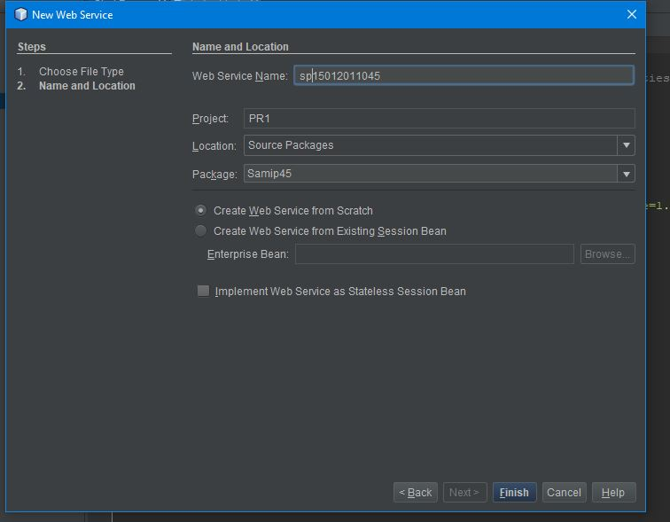

2. Add different operations.

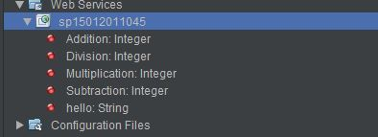

3. Deploy 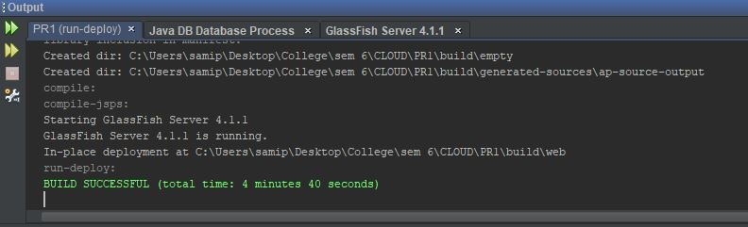

4. Test web service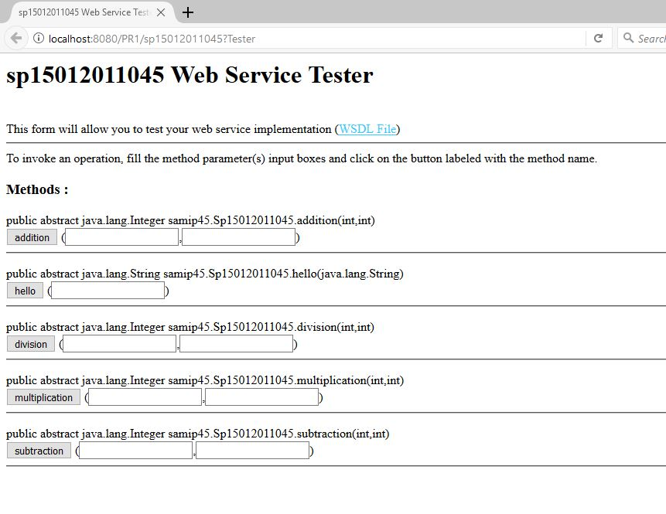

5. Create web service client and paste WSDL URL

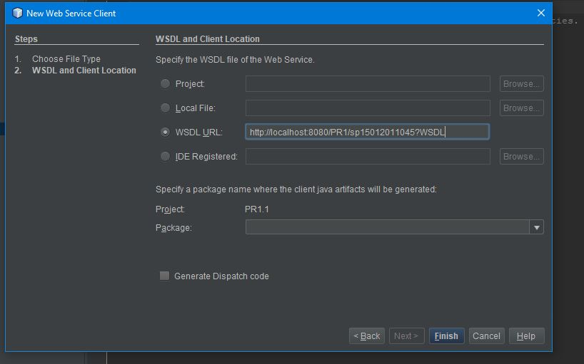

6. Insert code > Select all operations

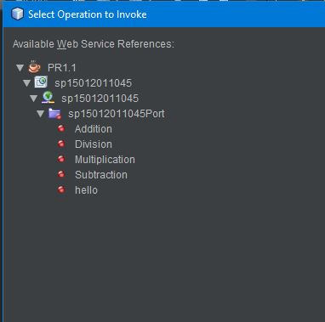

7. Run JAVA application

